**Lab Report No 2**



**Digital Signal Processing**

**Submitted By: Muhammad Saad**

Registration No: 21PWCSE1997

**Section: B**

**“On my honor , as student of University of Engineering and Technology, I have neither given nor received unauthorized assistance on this academic work”**

**Student Signature:**

**Department of Computer Systems Engineering**

**University of Engineering and Technology Peshawar**

**CSE 402L: Digital Signal Processing**

|  |  |  |  |  |
| --- | --- | --- | --- | --- |
| **Demonstration of Concepts** | **Poor (Does not meet expectation (1))**  The student failed to demonstrate a clear understanding of the assignment concepts | **Fair (Meet Expectation (2-3))**  The student demonstrated a clear understanding of some of the assignment concepts | **Good (Exceeds Expectation (4-5)**  The student demonstrated a clear understanding of the assignment concepts | **Score**  **30%** |
| **Accuracy** | The student completed ( <50%) tasks and provided MATLAB code and/or Simulink models with errors. Outputs shown are not correct in form of graphs (no labels) and/or tables along with incorrect analysis or remarks. | The student completed partial tasks (50% - <90%) with accurate MATLAB code and/or Simulink models. Correct outputs are shown in form of graphs (without labels) and/or tables along with correct analysis or remarks. | The student completed all required tasks (90%-100%) with accurate MATLAB code and/or Simulink models. Correct outputs are shown in form of labeled graphs and/or tables along with correct analysis or remarks. | **30%** |
| **Following Directions** | The student clearly failed to follow the verbal and written instructions to successfully complete the lab | The student failed to follow the some of the verbal and written instructions to successfully complete all requirements of the lab | The student followed the verbal and written instructions to successfully complete requirements of the lab | **20%** |
| **Time Utilization** | The student failed to complete even part of the lab in the allotted amount of time | The student failed to complete the entire lab in the allotted amount of time | The student completed the lab in its entirety in the allotted amount of time | **20%** |

Lab No: 2.

## Playing with MATLAB

The following steps will introduce you to MATLAB by letting you play with it.

1. Run the MATLAB help desk by typing doc.

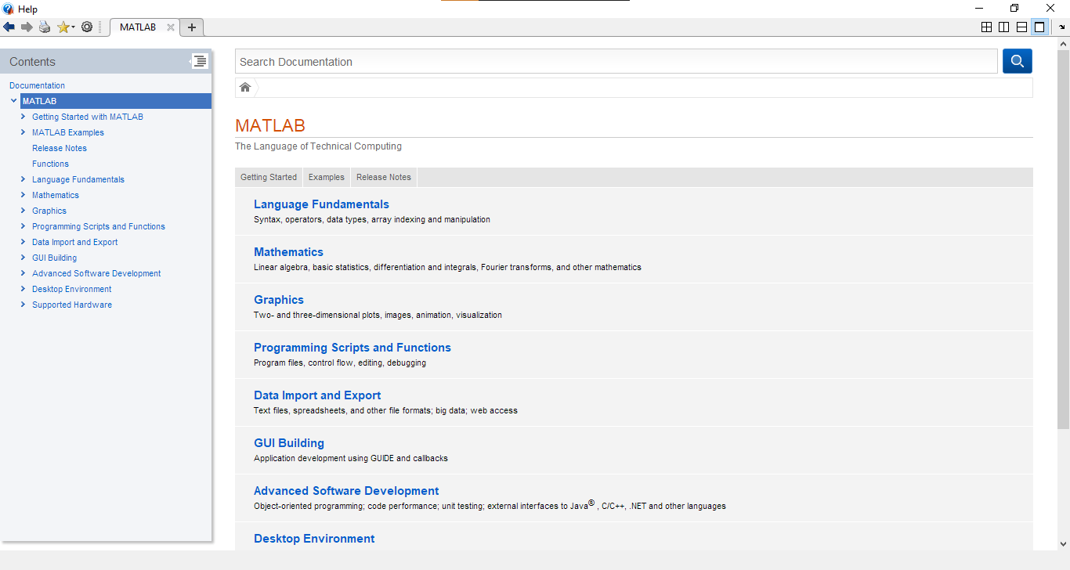Fig 01: Running ‘doc’ command

By running *doc* command we get access to a very extensive documentation of all the Mathwork products like Matlab, Simulink etc.

1. Explore the MATLAB helpwin capability available at the command line. Try the following:

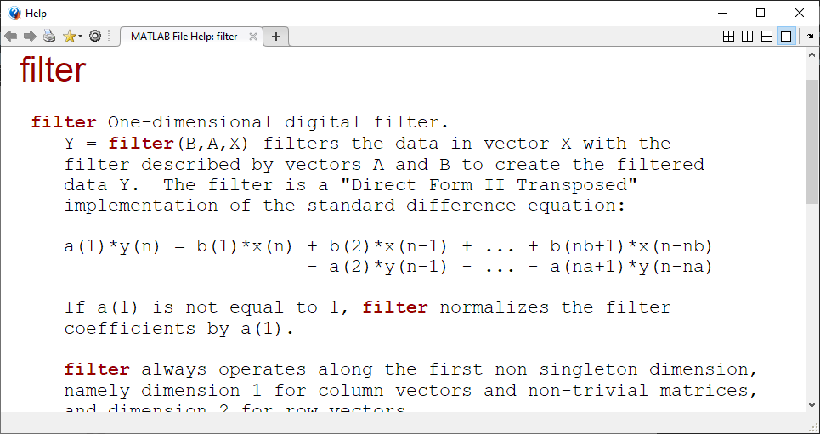

Fig 02: Running ‘helpwin filter’

Command *helpwin* show information about an individual function or method.

1. Run the MATLAB demos: type demo and explore a variety of basic MATLAB commands and plots.

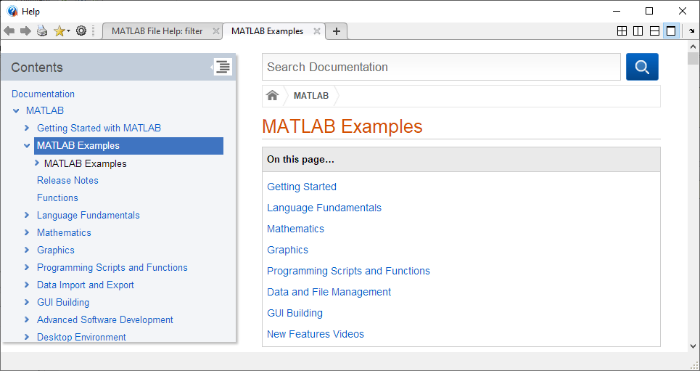Fig 03: *Demo* command

1. Use MATLAB as a calculator. Try the following:

pi*pi - 10

sin(pi/4)

ans ˆ 2 %<--- "ans" holds the last result

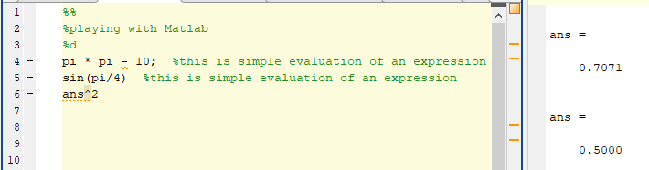Fig 04: B*asic Mathematic Evaluations*

1. Do variable name assignment in MATLAB. Try the following:

x = sin( pi/5 );

cos( pi/5 ) %<--- assigned to what?

y = sqrt( 1 - x*x )

ans

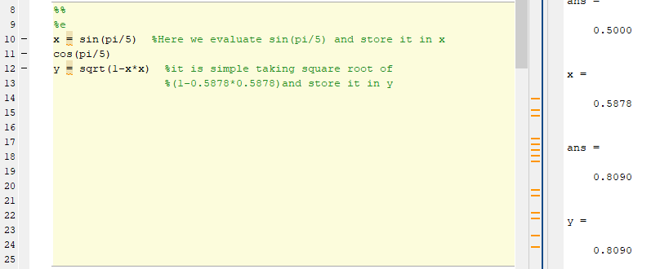Fig 05: B*asic Mathematic Evaluations*

1. Complex numbers are natural in MATLAB. The basic operations are supported. Try the following:

z = 3 + 4i, w = -3 + 4j

real(z), imag(z)

abs([z,w]) %<-- Vector constructor

conj(z+w)

angle(z)

exp( j*pi )

exp(j*[ pi/4, 0, -pi/4 ])

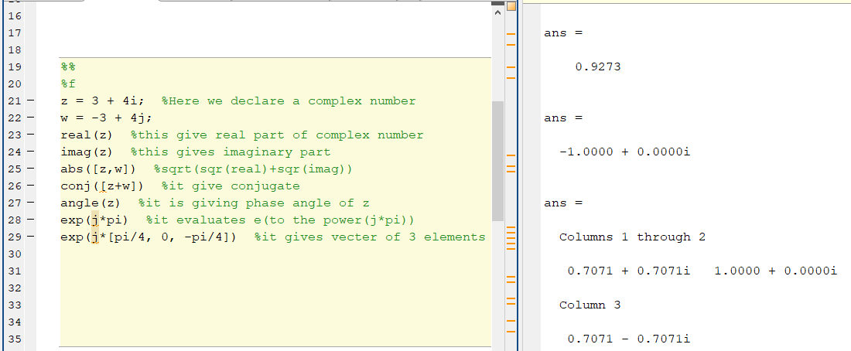Fig 06: B*asic Mathematic Evaluations*

# Warm-Up

## MATLAB Array Indexing

1. Make sure that you understand the colon notation. In particular, explain in words what the following MATLAB code will produce

jkl = 0 : 6

jkl = 2 : 4 : 17

jkl = 99 : -1 : 88

ttt = 2 : (1/9) : 4

tpi = pi * [ 0:0.1:2 ];

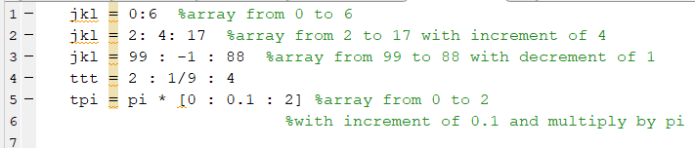Fig 07: B*asic Mathematic Evaluations (code)*

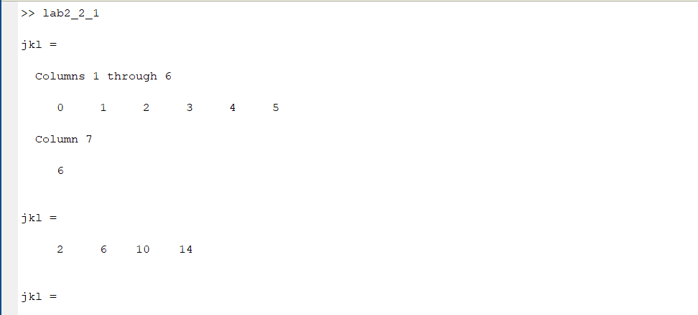*Fig 08: Basic Mathematic Evaluations (output)*

1. Extracting and/or inserting numbers into a vector is very easy to do. Consider the following definition of xx:

xx = [ zeros(1,3), linspace(0,1,5), ones(1,4) ]

xx(4:6)

size(xx)

length(xx)

xx(2:2:length(xx))

xx(2:2:end)

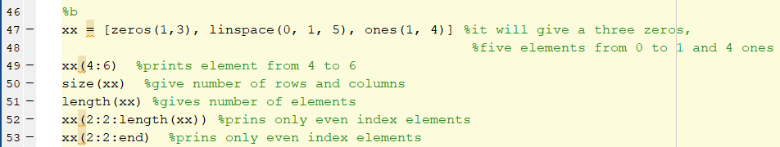*Fig 09: Operating on arrays (code)*

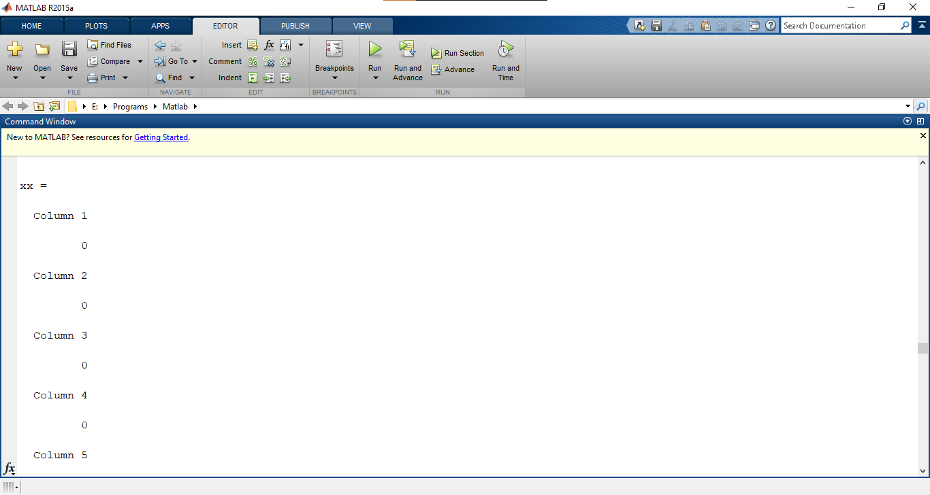*Fig 10: Operating on arrays (output)*

Explain the results echoed from the last four lines of the above code.

1. Observe the result of the following assignments:

yy = xx; yy(4:6) = pi*(1:3)

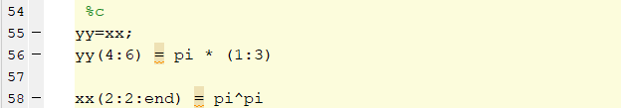*Fig 11: Operating on arrays (code)*

## MATLAB Script Files

1. Experiment with vectors in MATLAB. Think of the vector as a set of numbers. Try the following:

xk = cos( pi*(0:11)/4 ) %<---comment: compute cosines

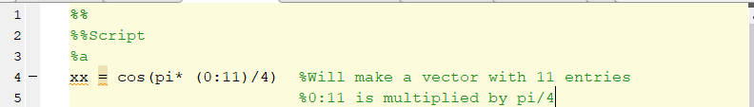*Fig 12: Vector of cosine (code)*

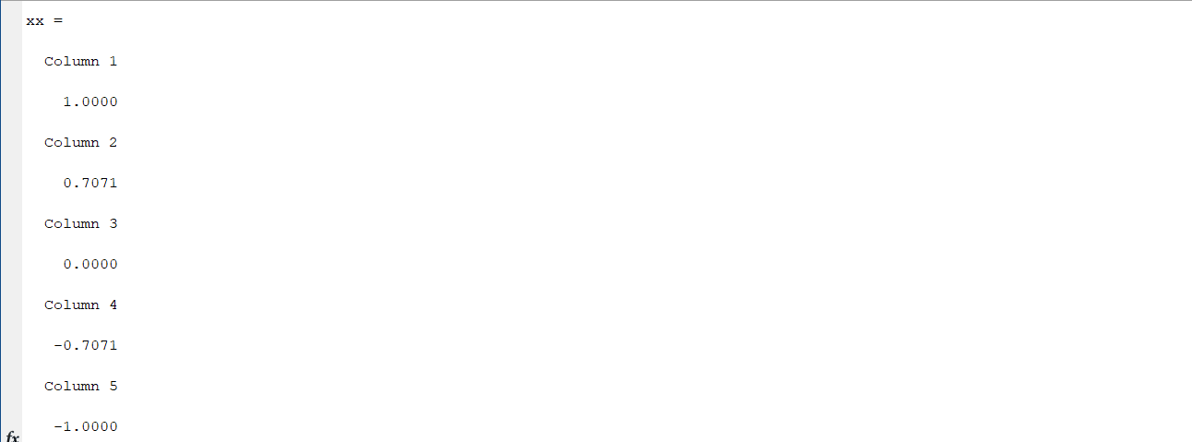

*Fig 13: Vector of cosine (output)*

1. (A taste of vectorization) Loops can be written in MATLAB, but they are NOT the most efficient way to get things done. It’s better to always avoid loops and use the colon notation instead.

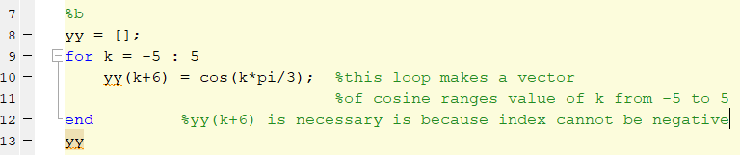*Fig 14: Vector of cosine (code)*

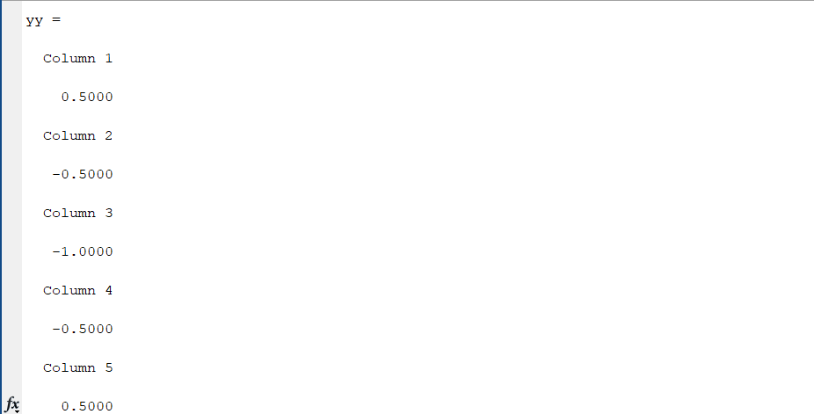

*Fig 15: Vector of cosine (output)*

1. Plotting is easy in MATLAB for both real and complex numbers. The basic plot command will plot a vector y versus a vector x connecting successive points by straight lines.

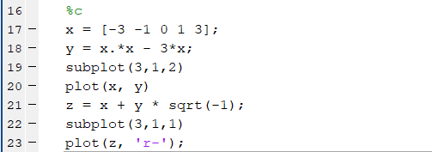

*Fig 16: Plotting a vector (code)*

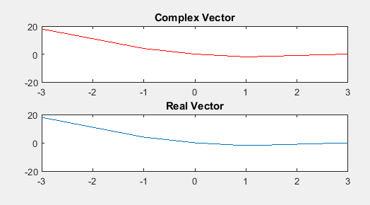

*Fig 17: Plotting vector(output)*

1. Use the built-in MATLAB editor to create a script file called mylab1.m containing the following lines:

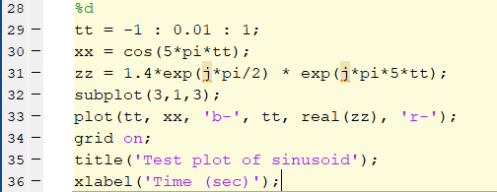

*Fig 18: Plotting vector(code)*

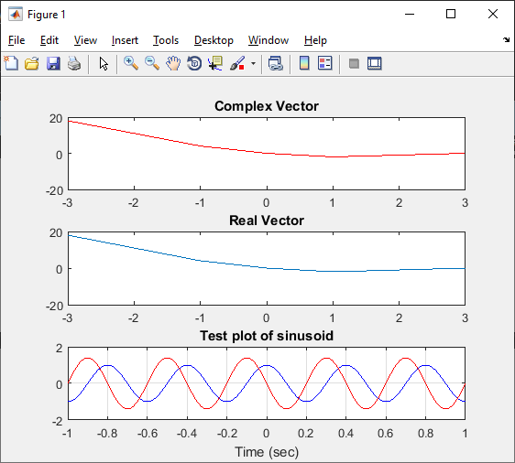

*Fig 20: Plotting vector(output)*

## MATLAB Sound

The exercises in this section involve sound signals, so you should bring headphones to the lab for listening.

1. Run the MATLAB sound demo by typing xpsound at the MATLAB prompt.

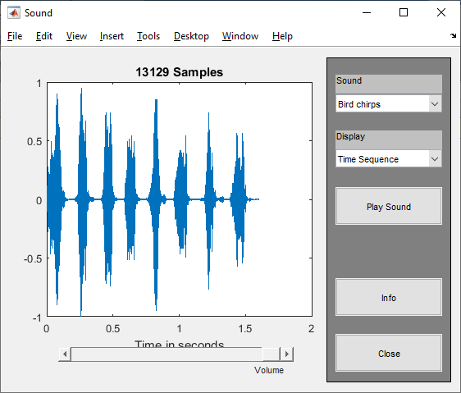

*Fig 21: By running ‘xpsound’ command*

1. Now generate a tone (i.e., a sinusoid) in MATLAB and listen to it with the soundsc() command.

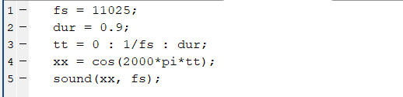

*Fig 22: Playing sound by using ‘sound()’ function*

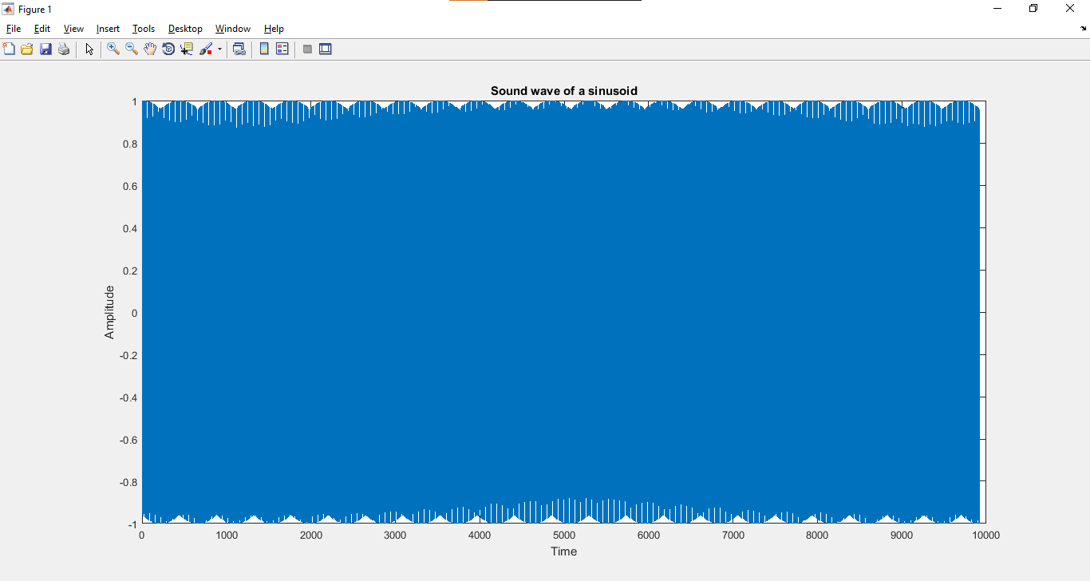*Fig 23: Playing sound by using ‘sound()’ function*

*_________________________________________________________________________________________*